Welsh Netball’s Performance Pathway Programme 2017/18
Are you ready to take the next step onto Welsh Netball’s Performance Pathway?
Welsh Netball are currently inviting players to trial for their Development & Performance Training Centre programme for the 2017/18 season.
What is a DTC/PTC?
The Performance Training Centres (PTC) and Development Training Centres (DTC) provide our young, talented netball players a values based learning environment where they can develop the necessary skills to progress within Welsh Netball’s Performance Pathway.
The PTC’s and DTC’s also provide development opportunities for our coaches, managers and umpires within Welsh Netball’s Performance Pathway.
There are currently 8 Performance Training Centres and Development Training Centre’s in locations throughout Wales. These include; Cardiff & The Vale, South East, Powys, North East, North West, West Wales, Glamorgan Valleys and Afan Nedd Tawe.
The PTC’s will include the top 25 players in the region (ages 16-20) and the DTC’s includes the top 25 younger players (ages 13-16).
Players attend trials based on the region their club or school is affiliated to. Schools and clubs then send nominations for players that are individually affiliated to Welsh Netball.
Our Performance Pathway (below) shows where the DTCs and PTCs currently sit within Welsh Netball:

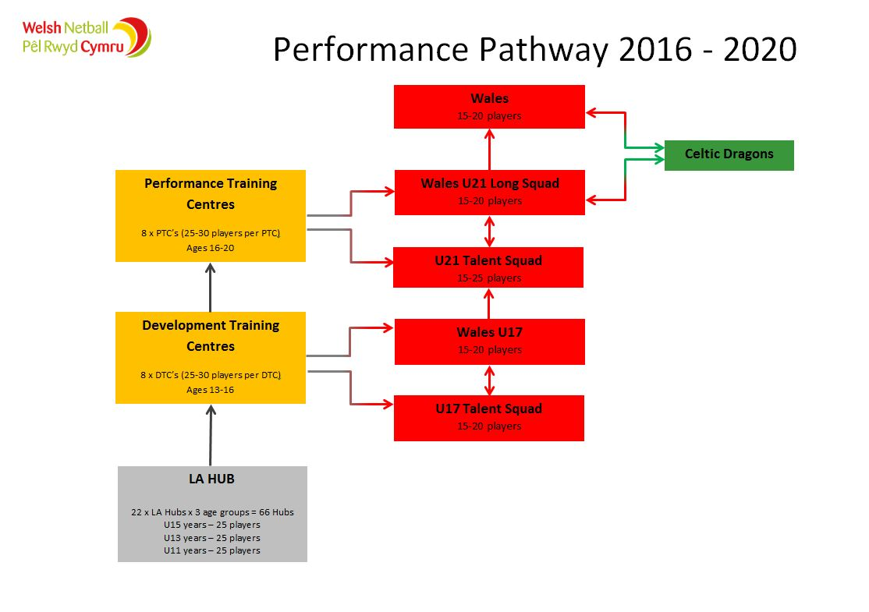
How to register for a trial
You can book on to trials using our member website: www.ourwelshnetball.co.uk.
If you experience difficulties registering for your trial online please contact the Welsh Netball office on 029 2033 4950.

Already a Welsh Netball member?
If you are already a Welsh Netball member you can log in to your personal account and then book on to a trial. To do this you will need your Welsh Netball affiliation number, which you can get from your Club Secretary/Coach. Your ‘USERNAME’ is your forename followed by your surname with a space in-between. Your ‘PASSWORD’ is your WN affiliation number.
Once you are logged in you can select the ‘Trials’ option on the homepage and then book onto the relevant trial for your age and where you live.

Not a Welsh Netball member?
Don’t worry, you can still register for a trial via the website. Select the ‘Trials’ option at the top of the homepage and this will take you to the list of available trials. You can then select the relevant trial for your age and where you live. Once you have entered the necessary personal details you will then be able to book onto the trial.

Key LA Hub information
- LA Hub trials are ‘open’. This means that you don’t have to be nominated by your club or school for a trial.
- There is a £5 registration fee per person for the trial.
- If successful in gaining a place within your DTC/PTC you will be required to pay a registration fee for the programme.
- Sessions are for 2 hours and take place once a month between the months of November – May/June with the DTC culminating in a tournament in July and the PTC playing in a tournament in May.
- Trials will be take place between October - November 2017.
- You will receive your own DTC/PTC t-shirt.
- Pre-registration using this form is required. Players who have not pre-registered will be unable to trial. Places are limited so register early to avoid disappointment.
- Players must be eligible to play for Wales to join the DTC/PTC programme.

For further information please contact the Performance Support Officer lucy.howells@welshnetball.com

