Go to www.ourwelshnetball.co.uk
Select the LOGIN button:
This will take you to the ‘log in’ screen, to enter the following:
Username – firstname(space)surname
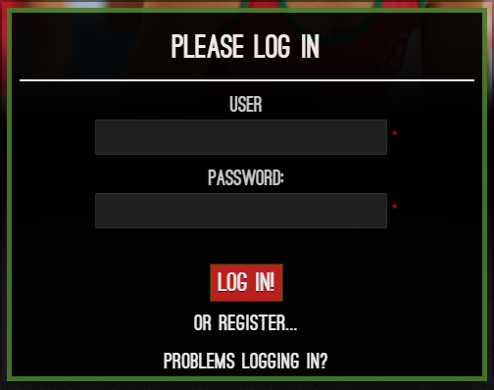
Password – Affiliation Number

Your affiliation number can be obtained from your Club Secretary. If you are still unable to log in after trying the above, please email welshnetball@welshnetball.com with two of the following details:
Full Name Affiliation number Date of Birth Email address Place of Birth

