APPENDIX 8
Injury/Accident Report Form
The following is an example of an Accident Report Form on which details of injuries, diseases and dangerous occurrences are notified.
Details of person injured:
Name:
Address:
Date of Birth:
Time and Date of Accident:
Was Accident Reported in Accident Record Book?
How did the Accident Occur?
Nature of Injuries:
Was First Aid given? ______________ By Whom? _____________________
Was Injured Person sent to Doctor, Medical Centre or Hospital? (Give Details)
If so, accompanied by whom?
Give Details of any Witnesses:
If the injured party is a child, have the parents been informed and, if so, by whom were they informed?
Any Previous Accident, which may have been due to same cause?
Was the Accident caused or contributed to by any defect in conditions or premises or the conditions of the facilities or equipment used? (If so, give details).
Name and signature of person reporting the accident:
Date:

What to do next
If advised to do so by the Club/League Safeguarding Officer, a photocopy of this form should be forwarded to them, or to the Business Support Officer, Welsh Netball Association, Sport Wales National Centre, Sophia Gardens, Cardiff CF11 9SW. Please mark the envelope “Private and Confidential” if posting.
Please retain the original copy of this form and any other original notes you have made, retaining these in a private and secure location.
Data protection
The Club, the relevant Area Association(s) and Welsh Netball Association Ltd shall each use the information in this form (together with other information they obtain as a result of any investigation) (together “Information”) to investigate the alleged incident, to follow the Welsh Netball Association’s Policy for Safeguarding Children and to take whatever action is deemed appropriate. This may involve disclosing certain information to a number of organisations and individuals including relevant clubs and individuals that are the subject of an investigation and/or governmental authorities such as the police, children’s social care, the Courts and/or probation officers and, potentially to legal and other advisers involved in an investigation. As the person completing this form, you must notify each person whose information you include about what shall happen to their information and how it may be disclosed except to the extent that doing so would prejudice either the prevention or detection of a crime or the apprehension or prosecution of an offender.
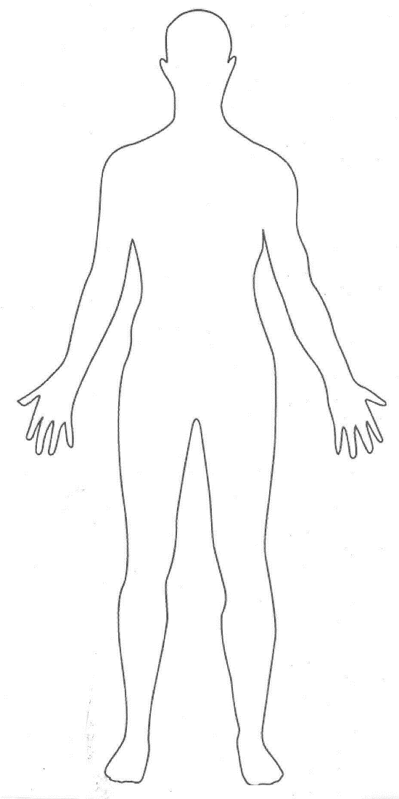
Please use the figure below to draw/circle any bruises or marks if appropriate:

